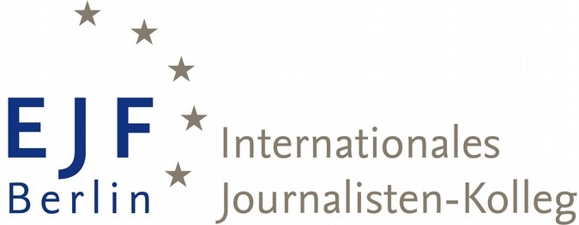

--- EJO Fellowship at EUROPEAN JOURNALISM-FELLOWSHIPS in BERLIN ---
FU-Programme cooperates with European Journalism Observatory (EJO)

About the EJO Fellowship at EJF

Since 2012 one fellowship annually is earmarked for a journalist who would like to become a temporary correspondent of the European Journalism Observatory (www.ejo-online.eu), observing in particular recent developments in journalism research in Germany, but also the rapidly changing landscape of journalism and media in Berlin.
The EJO-EJF Fellow receives a monthly stipend of 1.100 € for the duration of 10 months.

About EJO

EJO is a network of research institutions. It builds bridges between the different journalism cultures across Europe and the U.S. and between media researchers and practitioners. By making results of media research accessible, by studying “best practices” in journalism and by studying and comparing trends and in the media industry, the European Journalism Observatory (EJO – www.ejo-online.eu and www.ejo.ch) contributes to the improvement of quality in journalism and to a better understanding of the media by the public. EJO’s work is focussed on the needs of journalists and media managers, but it also serves students and other target groups who are interested in the development of media, reducing the gap between communications research and the world outside the ivory tower. As a joint venture, EJO partner institutions offer a multilingual website in ten European languages.

Activities of the EJO-EJF-Fellow

Instead of providing one project idea as part of their application, applicants for this fellowship hand in several story ideas on which they would like to work during their stay in Berlin. During the fellowship, the “EJO correspondent in residence at EJF” will contribute, in close cooperation with one of the EJO editors, monthly
- two or three own articles, making research results more accessible to journalists, media managers, students and other interested users to the EJO network and try to publish them additionally elsewhere in an adapt medium of his/her home country;
- several postings on the EJO website of his native language (some of them may be translations from other EJO websites, in particular the German and English one);
- links to the EJO Twitter and/or Facebook pages.

According to the needs of EJO, the fellow may also get involved in editing work. This work should not exceed 20/25 percent of the time budget of the fellow.

Requirements which need to be fulfilled by the applicants

- journalistic experience
- strong interest in journalism & media research
- the mothertongue needs to be one of the existing EJO languages: Albanian, Arabic, Czech, English, German, Hungarian, Italian, Latvian, Portugese, Polish, Romanian, Russian, Ukrainian
- basic knowledge of the German language (level A or B)

Application documents

- form letter + letter of motivation (personal statement)
- curriculum vitae in table form
- three or four story ideas (short descriptions), on which the applicant would like to work during his/her stay in Berlin (concerning the landscape of journalism and media in Berlin and journalism research in Germany)
- copies of academic diplomas, certificates (if existing)
- one letter of recommendation (in English or German)
- two articles or other samples of applicant´s work
- proof of knowledge of the German language (DAAD or Goethe Institute) – can be handed in later

All documents need to be handed in by post and in German or English!

Selection of fellow

Decisions about this fellowship will be made jointly by a jury of two EJO and two EJF media experts and one external journalist who is invited on mutual agreement between the EJO and the EJF director.

Closing date for applications

March 26, 2018 (receipt deadline)
ATTENTION: NEW ADRESS

For more detailed information and application form please contact:
NEW ADRESS:

Europäische Journalisten-Fellowships Internationales Journalisten-Kolleg Freie Universität Berlin
Institut für Publizistik- und Kommunikationswissenschaft
Zu Hd. Frau Mechthild Petratis
Garystr. 55
14195 Berlin Germany
Telephone: ++49 / (0)30 / 838 - 533 15
Telefax: ++49 / (0)30 / 838 - 533 05

Internet: www.ejf.fu-berlin.de
E-mail: ejf@zedat.fu-berlin.de

