“Physics and the New Economy”
A Talk with Dr. Sabine O’Hara
Wed. June 11, 2014, 16:00-18:00
Ihnestrasse 22, Room 3.16, Freie Univ. Berlin

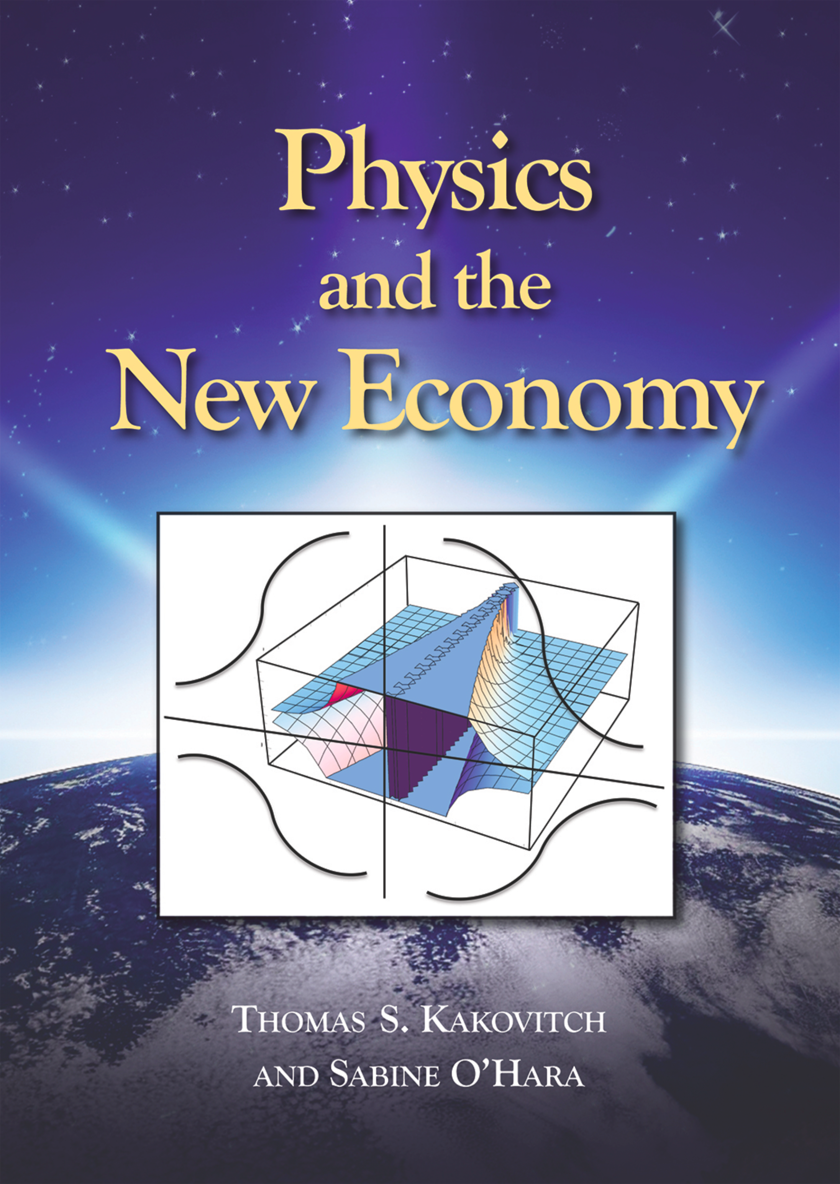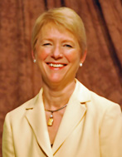

Questions about the characteristics of an economy that meets the needs of the current world population without impeding the needs of future generations have been at the center of the sustainability debate. At a world population of over seven billion, it is becoming ever more pressing that we find operational answers to these questions before we run out of options. Economists from Malthus (1766 – 1834) to the Club of Rome (1968) have warned that population growth would outpace our ability to meet long-term resources needs. While these warnings suggest awareness of the physical constraints of economic activity, the focus was mainly on the resource side of the economic process. Long-term sustainability was therefore chiefly concerned with the need to maintain material and energy resources to fuel human economic activity in the long run.

This book argues that the real constraint to economic activity lies not on the (re)source side, but on the sink side of the economic process. While it is certainly true that all production depends on the availability of sources (resource allocation) to be processed into output of useful goods and services, this process of resource transformation is invariably accompanied by the creation of byproducts of waste and emissions. The real constraint to economic activity lies therefore in the ability to process these unintended by-products of the production process. As waste and emissions are released into their social/cultural and physical/ environmental context, they are processed, absorbed, buffered, and accumulated in a set of context systems we call the social and natural environment. This constant release poses pressures on sinks including rivers, groundwater layers, oceans, soils, air, and the earth’s atmosphere; but also on families, communities and cultures. Eventually the capacity of sinks to process these constant inflows of emissions and waste becomes impaired and disorder grows.

Physics therefore demands the attention of economics. No economy can place itself outside of the physical realities of planet Earth. This means that the field of economics must be concerned with more than the (re)sources necessary to sustain economic production; sinks that provide the capacity to reduce the disorder created by the emissions and waste byproducts of economic activity must also be sustained.

We propose the expansion of the concept of economic production to include the following five characteristics of the new economy: (1) sustain sources, (2) strengthen/support sinks, (3) enhance diversity, (4) maintain a temperature range that sustains life, and (5) lower information disorder while increasing access to useful information.

We offer several examples of this new economy and show how it can utilize innovative decentralized, technologies to support the principles of the New Economy both on the environmental and on the social context side. We argue that kind of economy abandons the current course of violating physical constraints and it patterns itself instead after the physical/natural reality within which it exists.

------------
Dr. Sabine O'Hara is the Dean of the College of Agriculture, Urban Sustainability & Environmental Sciences (CAUSES) of the University of the District of Columbia (UDC). She is a respected author, researcher and higher education executive and is well known for her expertise in sustainable economic development, global education and executive leadership.
Dr. O'Hara was the founder of Global Ecology LLC, the 10th President of Roanoke College in Salem, Virginia, and held faculty and administrative positions at Concordia College in Moorhead, MN, at Green Mountain College in Poultney, VT, at Rensselaer Polytechnic Institute in Troy, NY, and as Executive Director of the Council for International Exchange of Scholars (CIES) a preeminent international exchange organization that administers the Fulbright Scholar Program.
A native of Germany, O'Hara earned a doctorate in environmental economics and a master's degree in agricultural economics from the University of Göttingen, Germany. She serves on the board of directors of several national and international organizations, including as past president of the United States Society for Ecological Economics, as International Advisory Board member of King Abdul-Aziz University in Jeddah, and as reviewer and editorial board member of several academic journals

