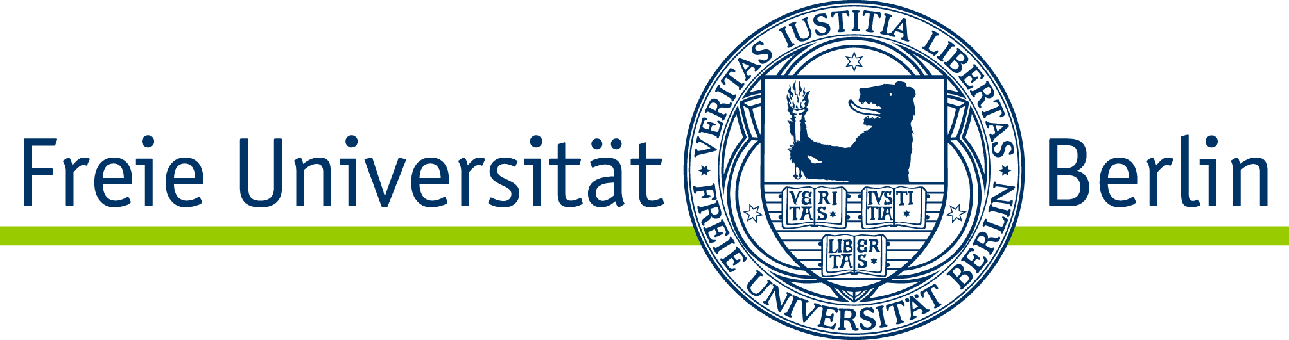
Department of Political and Social Sciences
Institute for Media and Communication Studies

List of Courses

M.A. Media and Political Communication

Student’s Name:
Student’s ID:
Semester:
Creation Date:

Module | Courses  Examination Form | Semester | Credits (ECTS) | Grade
Political Communication Management and Public Affairs | Main Seminar:  Exercise:  Term Paper |  | 15
Political Journalism | Main Seminar:  Exercise:  Special Term Paper |  | 15
Political Communication Research Methods | Lecture:  Lecture:  Exercise:  Written Exam |  | 15
Structures and Management of Political Communication | Main Seminar:  Term Paper |  | 15
History and Culture of Political Communication | Main Seminar:  Term Paper |  | 15
Theories and Findings of Political Communication Research | Main Seminar:  Lecture:  Term Paper |  | 15
Research Colloquium | Colloquium |  | 5
Master´s Thesis  (Title) |  |  | 25
Final ECTS and Grade |  |  | 120

Stamp (Examination Office)
Signature (Examination Office): ___________________________

